CO2 Emissions Considerations for the

Development of Canadian Tar Sands

And The Potential For Positive Impact On The Decision To Build The Keystone Pipeline

Prof. Alexander H. Slocum ([slocum@mit.edu](mailto:slocum@mit.edu))

Massachusetts Institute of Technology

Santiago Paiva ([paiva.santiago@gmail.com](mailto:paiva.santiago@gmail.com))

Undergraduate Student, McGill University

**Abstract**

In this paper we demonstrate that if 20% of Canadian Tar Sands Oil income were to be invested in renewable-energy machines as part of reclamation efforts for the land that is mined for the tar sands, then in 20-30 years as much CO2 will have been kept from the air from burning coal to make electricity as was released into the air from mining the tar sands and consuming the oil.

Contents

1 Introduction 2

1.1 Motivation 2

1.2 Problem Domain 2

2 Alberta's Tar Sands Oil Overview 4

2.1 Mining and Production of Tar Sands 4

2.2 The Keystone XL Pipeline 4

2.3 Social, Environmental, and Health Impact 5

3 CO2 Saved From Investing in Wind Energy 6

4 CO2 Saved From Investing in Solar Energy 8

5 Hybrid Model: Wind Turbines and PV Solar Cells 9

6 Conclusion 9

References 11

# 1 Introduction

## 1.1 Motivation

Beneath the boreal forest in Northern Canada lies the world's 2nd largest oil reserve, known as the tar sands. The tar sands are a mixture of sand and a heavy crude oil called bitumen. Natural bitumen is reported in 598 deposits in 23 countries, with the largest deposits in Canada, Kazakhstan, and Russia. Bitumen reserves are estimated at 249.67 billion barrels out of which 178 billion barrels (70.8%) are in Canada (Alberta) [1].

The Northern Alberta region contains 98% of the Canadian tar sand oil industry and it is divided into three regions:

* The Athabasca-Wabiskaw deposits region
* The Cold Lake deposits region
* The Peace River deposits region

Together, they cover 140,200 square kilometers. [2], which is an area larger than England. It is also estimated by the Government of Canada that these regions hold proven reserves up to 1.75 trillion barrels of bitumen in place. [9] In addition, 173 billion barrels (10%) is estimated to be recoverable at current prices using current technology. This amounts to 97% of Canadian Oil reserves and 75% of total North American petroleum reserves. It is further estimated that 90% of the Alberta oil sands are too far below the surface to use open-pit mining.

As a consequence of being able to develop such a large resource of petroleum, the Canadian government has been lobbying heavily for the creation of the Keystone XL pipeline. On the other hand, it has been argued that the environmental and health factors resulting from completion of the pipeline outweighs the benefits. In this paper, we demonstrate that if a modest portion of oil revenues are invested in renewable energy machines (e.g., wind and solar) to be included as part of land reclamation will not only result in a significant long term net reduction of CO2 emissions, but will build a strong renewable energy industry for the future of Alberta and the country.

## 1.2 Problem Domain

Alberta's Tar Sands are being mined over a vast area which will destroy large swaths of forests releasing even more carbon into the atmosphere. Just mining the oil and consuming it could have a huge impact on climate change.

**Hypothesis:**

*The effect on climate change does not have to be negative IF as part of land reclamation of the mined tar sands area, developers of the tar sands resource were required to plan and invest for when the tar sands are depleted: This could include for example, for every square kilometer of land to be reclaimed, a 5 MW wind turbine is installed.*

Figure 1 below shows the cumulative effect over the years of this land reclamation plan, with 50% of the total tar sands land area being reclaimed with wind turbines. Similar requires are obtained with 10% of the area reclaimed using arrays of PV cells.

This requires the tar sands developers to invest a portion of sales, $20/bbl for the scenario here, into renewable energy production; however, this is not a tax in which money is paid to the government and the companies never receive a direct benefit. On the contrary, the money invested benefits the tar sands companies directly and immediatly because they can use the electric power for production of the tar sands instead of having to build more transmission lines to bring power in for which they then have to pay to use. Furthermore, once the number of turbines increases to a point, they can start sending power out on the same lines they initially had installed (are in the process of installing) to develop the tar sands.

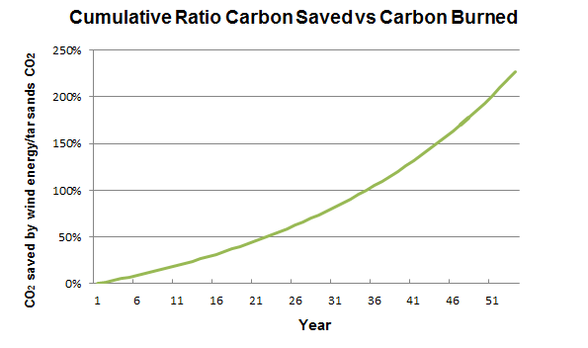

**Figure 1: Amount of CO2 offset by 20% investment in Wind Turbines**

# 

**Figure 2: Amount of CO2 offset by 20% investment in PV Solar Cells**

# 2 Alberta's Tar Sands Oil Overview

## 2.1 Mining and Production of Tar Sands

Per day, tar sands operation release as much CO2 as all the cars in Canada

[8]. Enough natural gas is burned to heat 4 million homes daily, while local upgraders emit 300 tonnes of sulphur. The Athabasca River is part of the third largest watershed in the world. Processing one barrel of bitumen requires approximately three barrels of water [8]. The toxic water is then pumped into giant tailings ponds alongside the shore.

According to a report released in 2011 [3], production of tar sands released an estimated of 47.1 million metric tonnes of CO2 into the air. Considering that in 2011, 1.8 million barrels a day were produced, we obtain the following chart:

**Table 1: CO2 from Tar Sands production and oil use**

|  |  |
| --- | --- |
| **Production** | **Use** |
| Oil produced (million barrels per year) | 693.5 |
| CO2 to produce the oil (megatonnes/year) | 50 |
| CO2 from oil use (megatonnes/year) | 298.2 |
| Total CO2 from tar sands (megatonnes/year) | 348 |

The recent announcement of the Keystone XL pipeline would allow the tar sand oil industry to propel mining and production to a whole new level. However, it raises the question: is the proposed Keystone XL pipeline the most environmental friendly option compared to other alternatives? There is a better alternative.

## 2.2 The Keystone XL Pipeline

As mentioned, the pipeline is a major milestone in the next phase of extracting tar sands under Canada's Boreal Forest to reach higher prices of overseas markets.

Projected Impact of Keystone XL by FEIS [4]:

* Projected 830,000 barrels/day flow
* Adds between 147 to 168 million metric tons of greenhouse gas emissions annually
* According to FEIS, the pipeline would be unlikely to significantly impact the rate of extraction in the oil sands, or the continued demand for heavy crude oil at refineries in the United States." Those greenhouse gas emissions from tar sands oil would probably be produced with or without Keystone.

In a recent article by Environment News Service, two senators called on the Secretary of State John Kerry and the Obama Administration to conduct “an immediate and comprehensive study" of the public health risks to communities from the proposed Keystone XL pipeline would carry diluted bitumen from Alberta across the US-Canada border to refineries on the Texas Gulf Coast. [5].

Canada's position has been clear: tar sands will be mined whether or not Keystone XL ever gets built; However here present an option that would benefit the tar sands mining companies, the government and people of Canada, and should turn many US opponents of the pipeline into supporters.

## 2.3 Social, Environmental, and Health Impact

Some of the issues at hand as reported in the media are:

1. **Water Contamination.** An article from Bloomberg BusinessWeek focuses on Canada's Alberta province putting forth man-made lakes, cited to be a by-product of the oil sands industry, with companies including Syncrude Canada, Royal Dutch Shell and ExxonMobil affiliate Imperial Oil running out of room to store the polluted water, a spin-off of the process used to turn bitumen into diesel and other fuels. It discusses the country's plans to build reservoirs filled with tar sands wastewater, which are predicted to cover almost 62,000 acres by 2020. [*Loon, Jeremy Van. Land of Tar Lakes. Bloomberg Businessweek 11/25/2013, Issue 4356, p15-16.*]
2. **Risk of accidents.** Pipelines spill more often than rail - over the past decade, pipelines have spilled 474,441 barrels of oil, compared to the 2,268 barrels spilled over the same time by rail. Pipeline spills also tend to be larger than rail spills - witness the 2010 Enbridge oil spill, when a burst pipeline led to more than 23,000 barrels of oil pouring into Michigan's Kalamazoo River. Fears over similar accidents have helped put the proposed Keystone XL pipeline on hold (environmentalists have raised concerns that spills involving oil sands crude will be especially difficult to clean). But pipeline spills remain rare as well, and the ones that do occur pose a more direct threat to the environment than to people - unlike rail accidents. [*Walsh, Bryan. North Dakota Derailment Shows Dark Side of America's Oil Boom. Time.com 1/2/2014, p1-1-1.*]
3. **Political view.** By letting the oil industry influence this process, Secretary (of State John Kerry) is undermining his long-established reputation as a leader in the fight against climate change. President Obama can end the debate if he felt sufficient scientific data existed to justify denying the Keystone XL pipeline. This decision could be a defining moment in his environmental legacy. *[Walsh, Bryan. Report Raises No Major Climate Objections to Keystone Pipeline, But the Choice Is Obama's Time.com 2/3/2014, p1-1-1*]

# 3 CO2 Saved From Investing in Wind Energy

The debate does not have to be so difficult, however, if a systems perspective is pursued; hence herein is proposed the following scenario:

If one were to put one 5MW wind turbine per kilometer square in a total of

70,100 kilometers square land area (50 % of the Alberta Tar sands area), it would require an investment of about 20% of the portion of the sales (e.g., $20/bbl). This approach would offset the CO2 created by mining and using the tar sands oil in approximately 35 years while producers can benefit from the use of electric power for mining and production of the tar sands. Furthermore, it is common for the return on investment period for a wind turbine to be about 10-15 years, which means the $20/bbl invested is actually fully recouped in 10-15 years and then onward the wind turbine becomes a net income producer.

It is estimated that the CO2 released (and captured) from boreal forest is about 26.2 tonnes/km2 [13]. This value is small compared to CO2 offset by having a large wind turbine (8500 tonnes/year/MW by not burning coal to produce energy generated by wind). Therefore, this is a strong motivation for tar sands land mining reclamation to not to just replant the forest, but to plant forest *and* a large high hub height wind turbine every square kilometer. Figure 3 shows different scenarios for different percentage of investment.

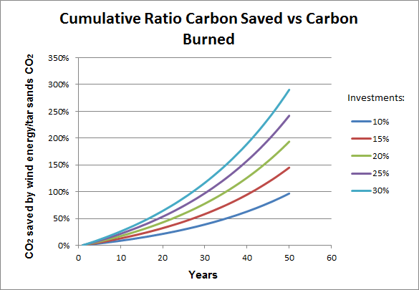

**Figure 3: Amounts of CO2 offset with different investments in Wind Energy**

**Technical details:**

|  |  |
| --- | --- |
| **Description** | **Value** |
| Turbine Peak Power (MW) | 5 |
| Capacity factor | 40% |
| Land area per turbine (km2) | 1 |
| Percent land area for wind turbines | 50 % |
| Area of wind farm (km2) | 70,100 |
| (Square Miles) | 27,383 |
| Square size (miles x miles) | 165 |
| Number of turbines to be built for land area | 70,100 |
| Average Power generated (GW) | 198 |
| Average annual energy produced (TWHr) | 1,734 |
| **CO2 saved by wind turbines (megatonnes/year)** | **1,684** |

**Assumptions:**

1. **Wind Turbine Peak Power**

* The choice of 5 MW/km2 is conservative and forthcoming are 7 MW turbines, although they will require larger spacing. Even 10 MW turbines are under consideration for production.

1. **Wind Turbine Capacity Factor**

* NRELs median capacity factor to be 40% for onshore wind turbines
* With higher hub heights, up to 140m, wind turbine net capacity factor could rise to 50%

1. **Land area per turbine**

* Land area assumed to cover 1 km2 per turbine, many wind farms actually would place up to two turbines in this area.

1. **Percent land area for wind turbines**

* Assumption to cover 50% of the total Alberta mined tar sands area.

# 4 CO2 Saved From Investing in Solar Energy

Wind power can produce energy 24/7 as long as the wind blows. For some regions solar, even as far North as the tar sands, might be an option. If one were to invest 20% of the portion of the sales ($20/bbl for this scenario) and put one 1600mm x 1020mm PV solar panel per 0.00163 kilometer square in a total of 14,020 kilometer square land area (10 % of the Alberta Tar sands area), then this approach would offset the CO2 created by mining and using the tar sands oil in approximately 20 years while producers could once again benefit from the use of electric power for mining and production of the tar sands. Figure 4 shows different scenarios for different percentage of investment.

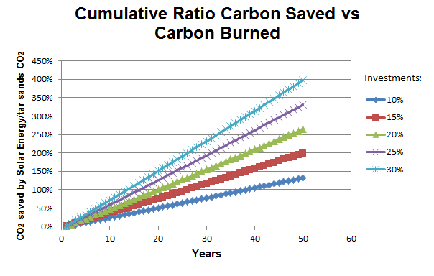

**Figure 4: Amounts of CO2 offset with different investments in Solar Energy**

**Technical details:**

|  |  |
| --- | --- |
| Description | Value |
| Peak power of solar cell (MW) | 0.00130 |
| Percent land area assumed covered by PV fields | 10% |
| Area of PV farm (km2) | 14,020 |
| (Square miles) | 5,477 |
| Square size (miles x miles) | 74 |
| Land area per solar panel (km2) | 0.00163 |
| Number of solar panels to be built for land area | 8,590,686 |
| Density of coverage on land designated for PV fields | 30% |
| Area of PV cells (m2) | 4,206,000,000 |
| PV cell efficiency | 15% |
| Average 24/7 solar insolation April (Wh/m2/day) |  |
| June | 6,250 |
| January | 1,389 |
| Average power (assumes 24/7 operation made possible with storage technology) (GW) |  |
| June | 164 |
| January | 37 |
| Average | 100.405 |
| **CO2 saved by not burning coal to produce energy generated by solar (magatonnes/year)** | **854** |

**Assumptions:**

1. **PV panel size and power**

* Assumption to be 1.3kW solar photovoltaic panel. In Alberta, a panel will typically have an average of between 1000 and 1400 kWh per year [10].
* Most solar panels come at roughly two sizes. We assume that this solar panel is 1600mm x 1020mm. [11]

1. **Percent land covered by PV fields**

* Assumption to cover 10% of land area.

1. **Density of coverage on land designated for PV fields**

* Assumption to cover 30% of land area

1. **Efficiency of PV fields**

* For this analysis, OPV efficiency was estimated to be only 15%.
* Dave DeGraaff, SunPower’s general manager, estimates PV cells efficiency to achieve 23% by 2015

1. **Cost of installation of PV fields**

* Estimated to be about $4/W [12]

# 5 Hybrid Model: Wind Turbines and PV Solar Cells

Forthcoming

# 6 Conclusion

It is appears to be economical and politically prudent to undertake as soon as possible a project to install 10 wind turbines on reclaimed land and study the project to ascertain true costs, risks, and benefits with respect to ultimately widespread application of this reclamation strategy.

In parallel, it would be good to conduct a detailed business analysis (short and long term return of investment) of the hypotheses presented here, including:

1. The requirement of investing 20% of gross income from tar sands into renewable energy sources as part of land reclamation and to provide electricity for processing the tar sands, and then selling excess electricity back to the grid.
2. The ability of a) above to encourage the US to approve of the Keystone pipeline
3. The time effect cost of releasing a lot more CO2 now in exchange for a long term greater reduction.

# References

[1] Attanasi, Emil D.; Meyer, Richard F. [*"Natural Bitumen and Extra-Heavy Oil*"](http://www.worldenergy.org/documents/ser_2010_report_1.pdf) (PDF). Survey of energy resources (22 ed.). [World Energy Council](http://en.wikipedia.org/wiki/World_Energy_Council). pp. 123–140. 2010.

[2] *About Oil Sands: Facts and Statistics*. Retrieved March 13, 2014, from

http://www.energy.alberta.ca/oilsands/791.asp

[3] http://www.scientificamerican.com/article/tar-sands-and-keystone-xl-pipeline-impact-on-global-warming/

[4] U.S Department of State. *The final environmental impact statement*

*(FEIS).* January 2014

[5] Prystupa, Mychaylo. *Alberta doctor tells U.S.: Canada is lying about tar*

*sands health effects*. Retrieved Feb 27, 2014, from

https://www.vancouverobserver.com/news/

[6] *Oil Shale/Tar Sands Guide.* Retrieved March 13, 2014, from

http://ostseis.anl.gov/guide/tarsands/index.cfm

[7] R.D White (Robert Douglas), *Global Environmental Harm: Criminal Per-*

*pectives*. Cullompton, Devon; Portland, Or.: Willan Pub. 2010.

[8] Mettler, Peter. *Petropolis: Aerial Perspectives on the Alberta Tar Sands.*

Documentary. 2009.

[9] [*Alberta's Oil Sands: Opportunity, Balance*](http://www.environment.alberta.ca/documents/Oil_Sands_Opportunity_Balance.pdf). Government of Alberta. March 2008. Retrieved March 19, 2014.

[10] <http://andrewleach.ca/climate-change/enmax-has-a-different-definition-of-affordable-than-i-do/>

[11] <http://greenforcesolar.com.au/knowledge-base/solar-panel-dimensions/>

[12] <http://www.smartplanet.com/blog/intelligent-energy/97-of-americans-overestimate-cost-of-installing-solar/15388>

[13] <http://www.forestecologynetwork.org/climate_change/sequestration_facts.html>